Universal Java Messaging

Design Document

February 13, 2003

Team Messengers

Tim (Shih Chen) Lau
Mariam Pessian
Nhut Tran
Kenny Vu
Michael Wong

Team Webpage: http://www.ics.uci.edu/~mwong/ics125.html

Client

Dr. Michael Franz
Associate Professor
Department of Information and Computer Science
University of California, Irvine
Table of Contents

Section Page

Introduction 3

Use Case Realizations 4

Logical Design 18

Detailed Design 19

UJaM Communication Protocol 27

Project Plan 29
Schedule 29
Project Risks 31

Glossary 32

Introduction

Instant messaging technology has become extremely prevalent among home users and, most recently, in schools and in the workplace. The latter two environments frequently have security measures in place, such as firewalls and port blocking, in order to protect themselves from hostile outside users and to conserve bandwidth. To make matters worse, leading messaging programs log all communication between users, which is a liability for any business that communicates via these channels. The answer to these problems is in UJaM (Univeral Java Messaging).

UJaM is an open-source instant messaging system that consolidates the basic features of instant messaging programs (e.g. custom usernames, chatting, keeping “buddies”) with the LAN-level control necessary to ensure security and economic bandwidth utilization. UJaM consists of a client control and a configurable server that can run on any machine on the network. Clients can connect to the server (client-server mode) or directly to each other (peer-to-peer) depending on the server configuration. If the server computer has access to the Internet, UJaM has the ability to connect into open-protocol external messaging systems, such as AOL Instant Messenger (AIM), Yahoo Messenger, MSN Messenger, ICQ, etc. The server is also capable of maintaining logs of all communications within the LAN.

The greatest feature of UJaM is the ability to locally control and manage the system through administrator tools. The administrator has the power to enable/disable communication to external messaging systems, change the connection mode of the users to either client-server or peer-to-peer, and has the last say in disputes concerning username rights. Businesses concerned with illegitimate conversations also have the option of searching and viewing communication logs. These options will let the administrator decide how the system will be most efficiently and appropriately used within the LAN.

Use Case Realizations

AddJammer Realization

Basic Course + Successful Alternate Courses

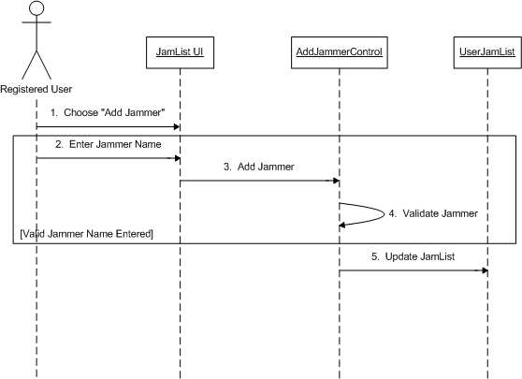
AdminChangeUserInfo Realization

Basic Course + Successful Alternate Courses

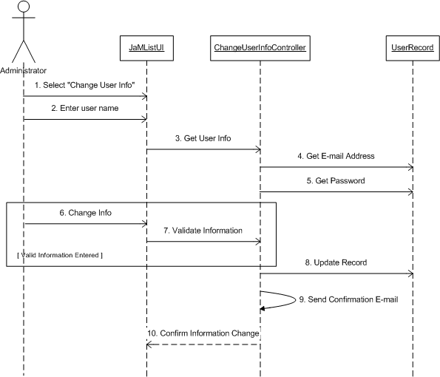

ChangeUserInfo Realization

Basic Course + Successful Alternate Courses

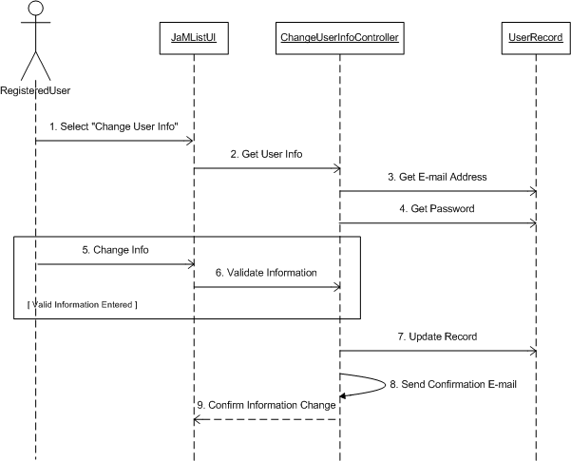

Chat Realization

Basic Course

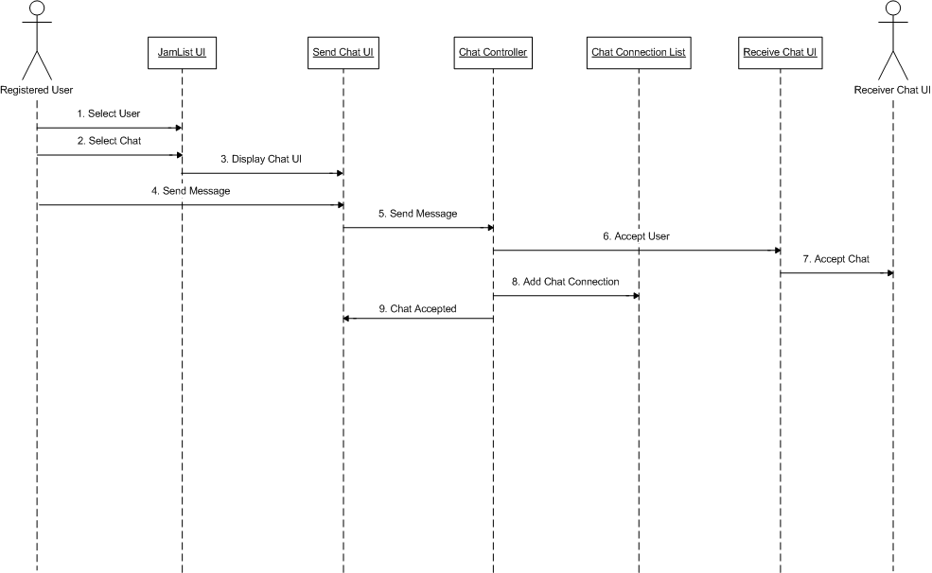

Unsuccessful Alternate Course 1

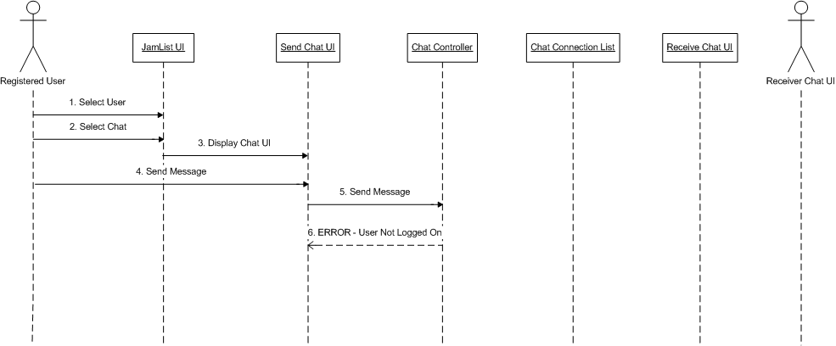
ConnectToAIM Realization

Basic Course

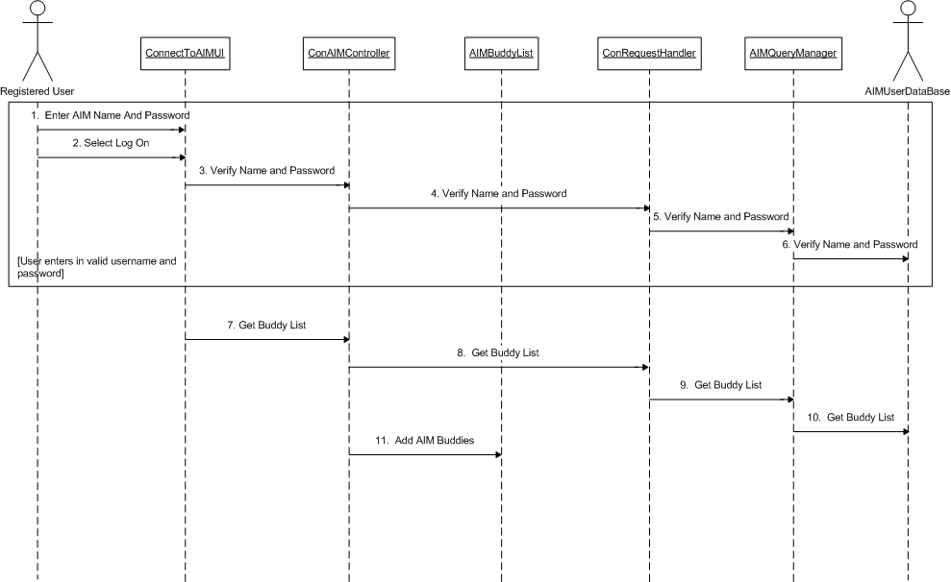
DeleteJammer Realization

Basic Course

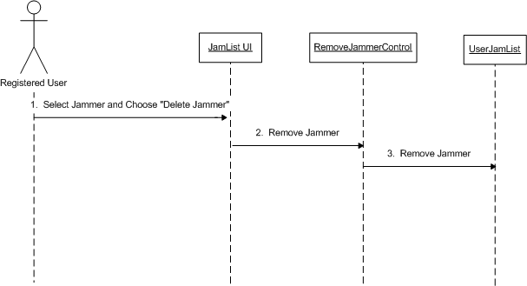

DisableExternalCommunication Realization

Basic Course

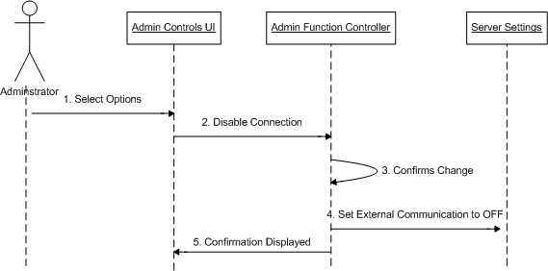

DisconnectFromAIM Realization

Basic Course

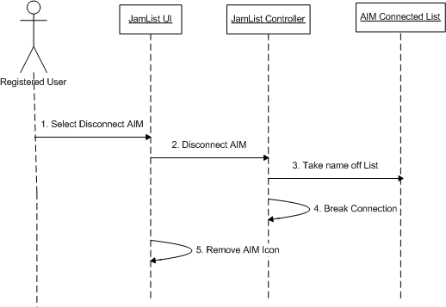

EnableExternalCommunication Realization

Basic Course

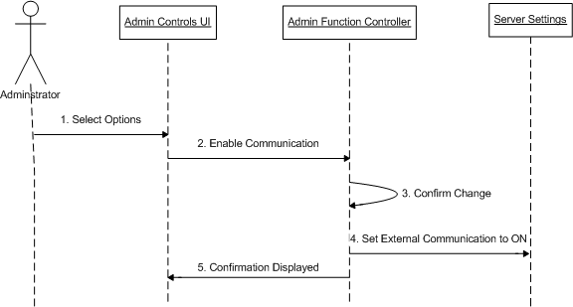

Logoff Realization

Basic Course

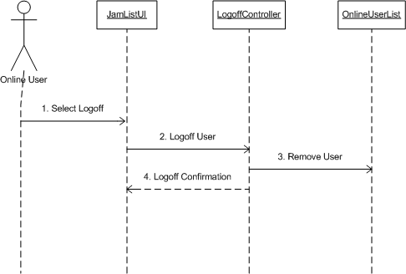

Logon Realization

Basic Course + Successful Alternate Courses

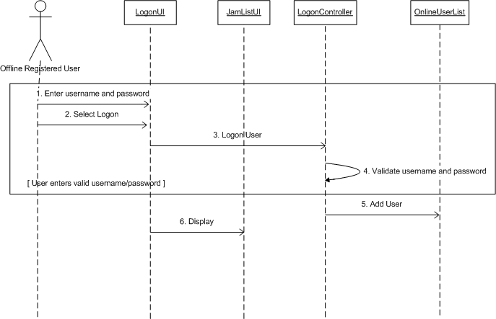

NewUser Realization

Basic Course + Successful Alternate Courses

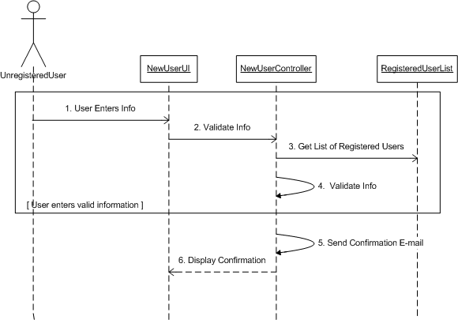

SetAwayMessage Realization

Basic Course

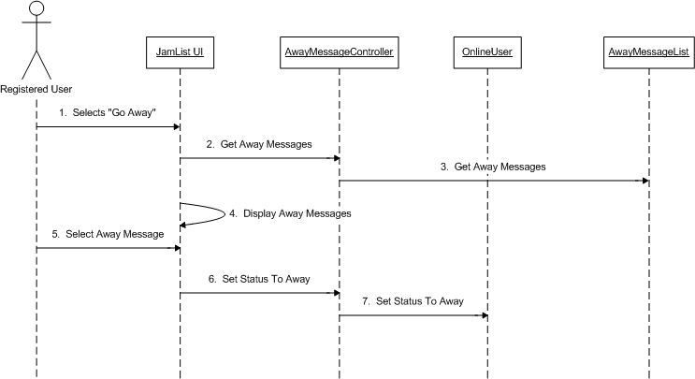

SetConnectionMode Realization

Basic Course

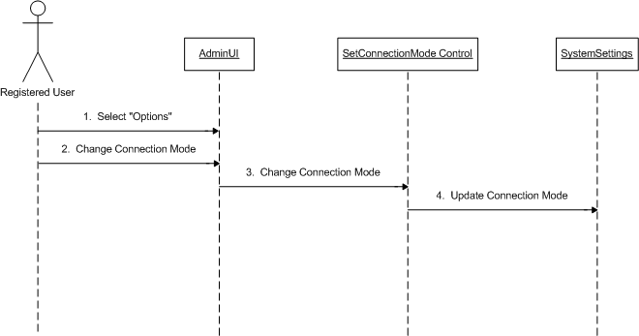

Logical Design

<< Boundary >> Package

- JaMListUI
- SendChatUI
- ConnectAIMUI
- AIMQueryManager
- AdminControlsUI
- LogonUI
- NewUserUI
- AdminUI

<< Control >> Package

- AddJammerController
- ChangeUserInfoController
- ChatController
- ConAIMController
- AIMConRequestHandler
- RemoveJammerController
- AdminFunctionController
- DisconnectAIMController
- LogoffController
- LogonController
- NewUserController
- AwayMessageController
- SetConnectionModeController

<< Entity >> Package

- UserJamList
- UserRecord
- ChatConnectionList
- AIMBuddyList
- AIMUserDatabase
- AIMConnectedList
- OnlineUserList
- RegisteredUserList
- AwayMessageList
- SystemSetting

Detailed Design

UJaM is organized into four packages or layers: Interfaces, Command, Network, and Data. The Interfaces layer is at the top level, containing all classes concerned with user interaction and high-level system control. The Command layer contains classes concerned with the interpretation of user actions to commands that the underlying system can understand. The Network layer contains classes concerned with low-level communication between client and server, i.e. network connections and client connection modes. The Data layer contains classes concerned with data handling, such as database management and abstract data types for object-oriented data storage and control.

UJaM: Main

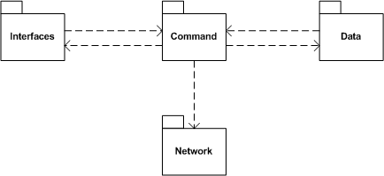

UJaM: Interface

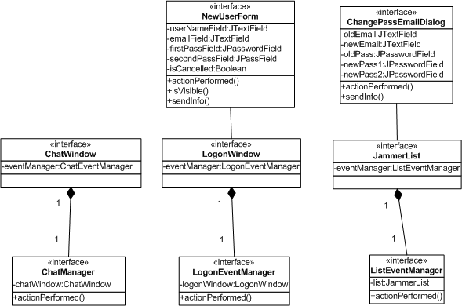

UJaM: Command

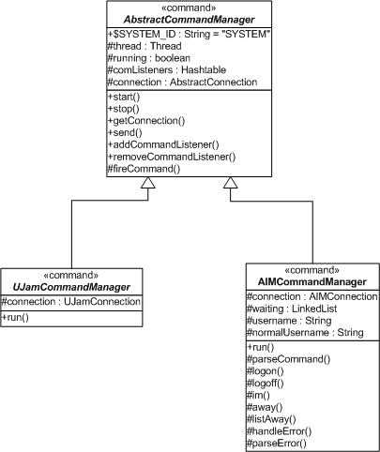

UJaM: Network

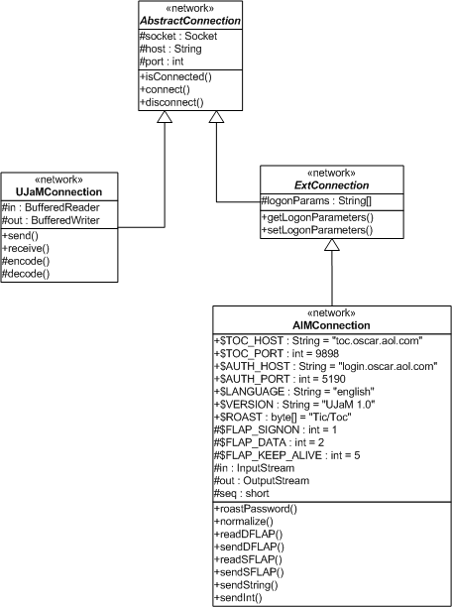

UJaM: Data

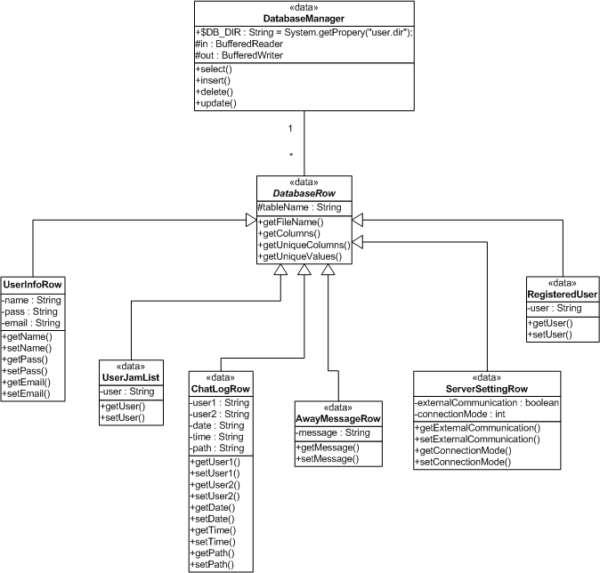

UJaM: Interface-Command Association

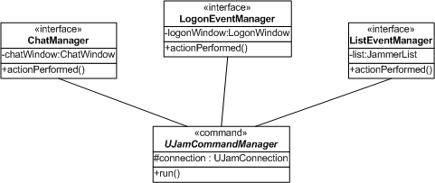

UJaM: Command-Network Association

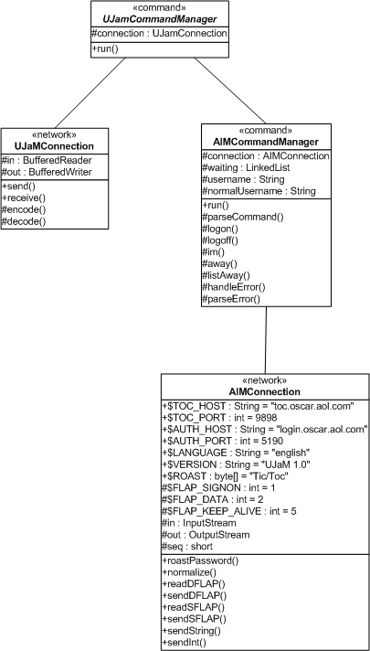

UJaM: Command-Data Association

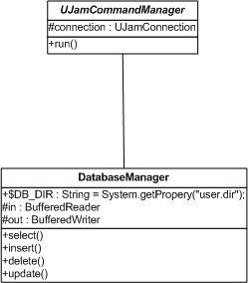

UJaM Communication Protocol
The following protocol is used to communicate between the UJaM Client and the UJaM Server. It has no relation to communication protocols for external messaging systems such as AIM, etc. The commands are formatted in XML for easier readability and to decrease parsing and conversion time on the server side.

(The following table lists all XML commands. The parent node is assumed to be “UJAM” unless otherwise specified.)

Node | Parent | Description
UJAM  [root] | [none] | The root node in every communiqué between client and server. If a communiqué is received that does not begin with this tag, it will be discarded, and an error returned to the sender.
ID |  | The unique identifier for this communiqué.
FROM |  | The user (or ‘SYSTEM’) sending the communiqué.
TO |  | The target user (or ‘SYSTEM’) of the communiqué.
ACK |  | The acknowledgement of some command. It may contain child nodes for more information depending on the command.
ERROR | ACK | If this is sent inside of an ACK, then some error has occurred and this node contains the error information.
USER |  | A user or administrator wants to create/update user information.
PASS | USER | Specifies the new password. (blank or non-existing mean unchanged).
EMAIL | USER | Specifies the new email address. (blank or non-existing mean unchanged).
LOGON |  | A user is attempting to logon to the system. This tag contains the password for the user.  When the system receives the command it will forward the command to all users that have this user on their Jam List.
LOGOFF |  | A user is logging off the system.  When the system receives the command it will forward the command to all users that have this user on their Jam List.
TALK |  | Sets up the connection between two clients regardless of peer to peer or client server connection.  When the system is in “client - server” mode, USER2 receives the TALK, it should return an ACK to USER1. When USER1 receives the ACK, they can begin the IM session. If USER2 sends a rejection ACK then USER1 will do nothing.  When the system is in “peer – peer” mode, USER2 receives the TALK, he will send an ACK to USER1 and begin listening for direct connection from USER1. When USER1 receives the ACK, it sets up connection to USER2 and begins IM session.  ACK values: 0 = reject, 1 = accept
IM |  | An instant message to the user specified in the ‘TO’ node.  If a user closes IM window, then session between them ends. Meaning if they want to talk again, the session would have to be reinitialized.
QUIET |  | Closes an IM session when a USER1 closes their IM window. If USER2 still has their window open and continues to send messages to USER1, then the IM session will have to be reinstated through the TALK command.
AWAY |  | Contains the away message chosen by the user (as returned by the LIST-AWAY command).  When the system receives the command it will forward the command to all users that have this user on their Jam List. If the chosen message is not on the user’s away message list, it will be added.
LIST-AWAY |  | An empty tag requesting a list of away messages for this user.
RETURN |  | An empty tag indicating this user has returned from being away.
LIST-JAM |  | An empty tag requesting a list of jammers for this user
ADD-JAM |  | Contains the user name to add to this user’s jammer list
DEL-JAM |  | Contains the user name to remove from this user’s jammer list
FILE-REQ |  | Request a file transfer to a user. The contents of this node will contain information about the file to send.
NAME | FILE-REQ | Contains the name of the file to be transferred.
SIZE | FILE-REQ | Contains the size (in bytes) of the file to be transferred.
FILE-SND |  | Send a file directly to a user. At this point there should be a direct connection to the target user’s client.
NAME | FILE-SND | Contains the name of the file to be transferred.
SIZE | FILE-SND | Contains the size (in bytes) of the file to be transferred.
DATA | FILE-SND | Contains the data of the file to be transferred.
EXT-LOGON |  | A user is attempting to log on to an external system.
TYPE | EXT-LOGON | The type of external system (e.g. AIM).
USER | EXT-LOGON | The username for the external system.
PASS | EXT-LOGON | The password for the external system.
EXT-LOGOFF |  | A user is logging off an external system (not necessarily from UJaM).
USER | EXT-LOGOFF | The username that is logging off.
TYPE | EXT-LOGOFF | The type of external system (e.g. AIM)
IDLE-TIME |  | The user is attempting to set their idle time to the specified number of minutes.
MAIL |  | The user is leaving a message for an offline user.
BLOCK |  | The user is blocking the specified user.
UNBLOCK |  | The user is unblocking the specified user.
EXT-TOGGLE |  | The administrator is toggling external communications.
MODE |  | The administrator is setting the communication mode.
LIST-ALL |  | The administrator is requesting a list of all users.
LIST-LOG |  | The administrator is searching for logs.
USER | LIST-LOG | The user search parameter (all users if blank or non-existing).
DATE | LIST-LOG | The date search parameter (all users if blank or non-existing).
TIME | LIST-LOG | The time search parameter (all users if blank or non-existing).
GET-LOG |  | The administrator is requesting a specific log file (as returned by LIST-LOG command).

Project Plan

Schedule
- Setup Team Webpage (01/07/2003 – 01/13/2003)
  - Tim, Michael
- Requirements Phase 1 (01/10/2003 – 01/17/2003)
  - Meet with Client and get initial requirements
    - All Team Members
  - Type initial Phase 1 requirements
    - Kenny
  - Edit Phase 1 requirements
    - All Team Members
  - Finalize Phase 1 requirements
    - Kenny
- Requirements Phase 2 (01/17/2003 – 01/24/2003)
  - Meet with client to further specify requirements
    - All Team Members
  - Write initial use and test cases
    - All Team Members
  - Gather and combine initial use cases
    - Mariam
  - Refine and finalize requirements phase 2
    - Michael, Kenny, Nhut
- Final Requirements Phase (1/24/2003 – 1/31/2003)
  - Meet with client to address any remaining concerns
    - All Team Members
  - Refine and finalize final requirements document
    - Tim, Mariam
  - Get requirements approved by client
    - All Team Members
- Design Iteration 1 (1/31/2003 – 02/07/2003)
  - Convert use cases to sequence diagrams
    - All Team Members
  - Combine diagrams from every team member
    - Kenny and Nhut
  - Refine and Finalize Design Iteration
    - All Team Members
- Design Iteration 2 (02/07/2003 – 02/14/2003)
  - Create classes and VOPC diagrams
    - All Team Members
  - Combine classes from all team members into a single document
    - Michael, Tim, Mariam
- Design Iteration 3 (02/14/2003 – 02/21/2003)
  - Refine and Finalize classes
    - All Team Members
  - Obtain document approval from Client
    - All Team Members
- Code Iteration 1 (01/24/2003 – 2/21/2003)
  - Background Research on messaging
    - Michael, Nhut, Kenny
  - GUI Prototype
    - Nhut, Tim
  - Creation of Command Classes
    - Michael, Kenny, Nhut
  - Research and Initial coding of AIM external connection
    - Michael
  - Initial Coding
    - Michael, Kenny
- Code Iteration 2 (2/21/2003 – 2/28/2003)
  - Coding of six required entity classes
    - Kenny
  - Coding of command classes, and external connections
    - Michael
  - GUI Finalization
    - Nhut, Tim
  - Refinement and Verification of Code.
    - All Team Members.
- Code Iteration 3 (2/28/2003 – 03/07/2003)
  - Module Testing
    - All
  - Code corrections
    - Michael, Kenny
  - Verification
    - Mariam
- Final Code Iteration (03/13/2003 – 03/13/2003)
  - Testing
    - Nhut, Tim, Mariam, Kenny
  - Code corrections
    - Kenny, Michael

Project Risks

Having done further work on this project has resulted in a re-evaluation of several project risks originally proposed in our requirements document. The risks which have required updating are as follows.

Knowledge Constraints

Description:
The team members have different skill sets, so not every member is familiar with design languages such as UML. Also, not all team members have experience with Java implementations of multi-threading, TCP/UDP sockets, e-mail, etc.
Update:
The diverse skill set provided by the team members has proven to be a good fit with assorted tasks that are required of this project. As a result, there have been no portions of this project, thus far, in which a lack of knowledge has resulted in a large setback.

Client Time Constraint

Description:
Our client is a professor at a University who occasionally goes out of town for long periods of time.
Update:
The client has always been available by some form of communication, whenever a pressing concern has arisen regarding requirements of the system.

Glossary
Administrator – The user of the system with additional rights to control server settings, view logs, and other supplementary options.

Client – A standard user of the system. Also referred to as a Jammer.

Jam List – List of users of the system and their online/offline status that is displayed for each user of the system.

Jammer – Refers to registered users of the system.

Username – The name under which a client appears as on the system.

