Universal Java Messaging

Design Document

February 13, 2003

Team Messengers

Tim (Shih Chen) Lau
Mariam Pessian
Nhut Tran
Kenny Vu
Michael Wong

Team Webpage: http://www.ics.uci.edu/~mwong/ics125.html

Client

Dr. Michael Franz
Associate Professor
Department of Information and Computer Science
University of California, Irvine
Table of Contents

Section Page

Introduction 3

Architectural Overview 4

Use Case Realizations 7

Logical Design 21

Detailed Design 22
Overview 22
Interface Level 23
Command Level 26
Network Level 28
Data Level 30

Integration Test Plan 37

UJaM Communication Protocol 51

Project Plan 54
Schedule 54
Project Risks 56

Glossary 57

Introduction

Instant messaging technology has become extremely prevalent among home users and, most recently, in schools and in the workplace. The latter two environments frequently have security measures in place, such as firewalls and port blocking, in order to protect themselves from hostile outside users and to conserve bandwidth. To make matters worse, leading messaging programs log all communication between users, which is a liability for any business that communicates via these channels. The answer to these problems is in UJaM (Univeral Java Messaging).

UJaM is an open-source instant messaging system that consolidates the basic features of instant messaging programs (e.g. custom usernames, chatting, keeping “buddies”) with the LAN-level control necessary to ensure security and economic bandwidth utilization. UJaM consists of a client control and a configurable server that can run on any machine on the network. Clients can connect to the server (client-server mode) or directly to each other (peer-to-peer) depending on the server configuration. If the server computer has access to the Internet, UJaM has the ability to connect into open-protocol external messaging systems, such as AOL Instant Messenger (AIM), Yahoo Messenger, MSN Messenger, ICQ, etc. The server is also capable of maintaining logs of all communications within the LAN.

The greatest feature of UJaM is the ability to locally control and manage the system through administrator tools. The administrator has the power to enable/disable communication to external messaging systems, change the connection mode of the users to either client-server or peer-to-peer, and has the last say in disputes concerning username rights. Businesses concerned with illegitimate conversations also have the option of searching and viewing communication logs. These options will let the administrator decide how the system will be most efficiently and appropriately used within the LAN.

Architectural Overview

Architectural Style

This software system is taking both a client-server architecture and a peer-to-peer architecture. What this means is for main system calls such as logging in and out, checking who is online, and requests to change user information must be done in client-server form. Any talking between Jammers would happen by a peer-to-peer connection. The sever also sends and retrieves information from our own custom made database.

Specifications for server protocol and database tables and functions are defined later in this document.

System Architecture Overview

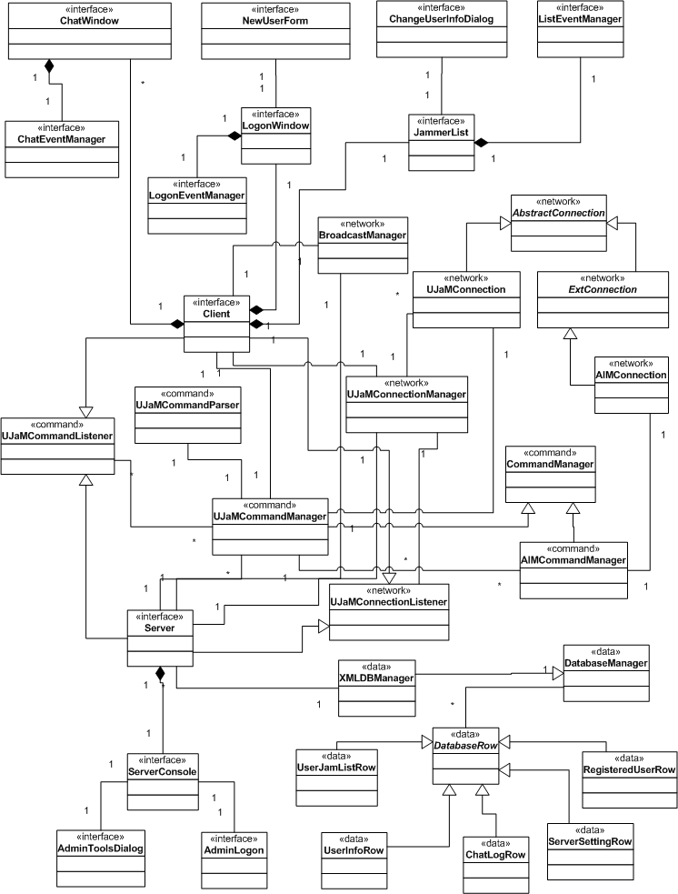

Subsystem Narrative

Database
This is a custom database that creates and loads XML files that are stored strategically on a local file system. While this may not be the most efficient implementation, it supports portability across platforms and ease of design, implementation, and reusability.

Server
This is a custom server designed to handle connections of the system. It allows interfacing between the users, other users, and the database. The server is designed such that there can be multiple servers on the same subnet. At this time, if a user logs onto one server, that user cannot see any users on any other servers and vice versa. Other users on a different server cannot see this user.

There is also an interface for the admin to perform administrative tasks on a particular server. This interface allows the administrator to control external communication to other chat programs and their networks.

Client
This is the interface for the regular user of the system. They can select which server to log on to, see who they can chat with and talk with other users. If external communication is enabled, Users will be able to chat with users of other chat programs.

Data
This represents the data of the users and other types of entities that the program needs. It is mostly stored on the custom server but can be extracted to convert into data that can be used by the client and server.

Command
This represents the bulk of the controllers that send information around to the other parts of the program. This section is important because it represents the links between all other parts of the system.

Major Limitations

This software will be limited to systems that currently have Java Virtual Machines installed. Also we are using Java SDK 1.4.1 which may not work completely with older JVMs. The extent to which our system is portable relies solely on the portability of the Java language. The system will also be limited due to the capability of our custom server. We have not performed any benchmark tests on the server or the database due to time constraints.

Another major limitation is that we at this time are not able to host a ‘global’ server so that people across networks can connect and all chat to each other. Everything is limited to internal networks.

Use Case Realizations

AddJammer Realization

Basic Course + Successful Alternate Courses

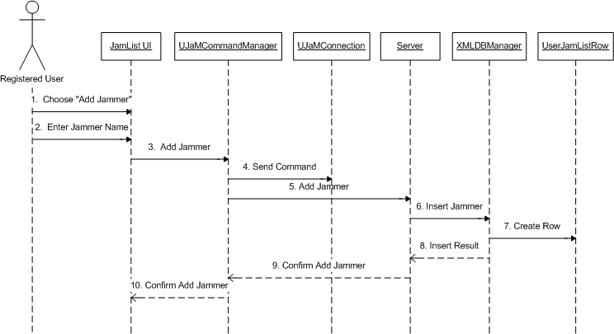
AdminChangeUserInfo Realization

Basic Course + Successful Alternate Courses

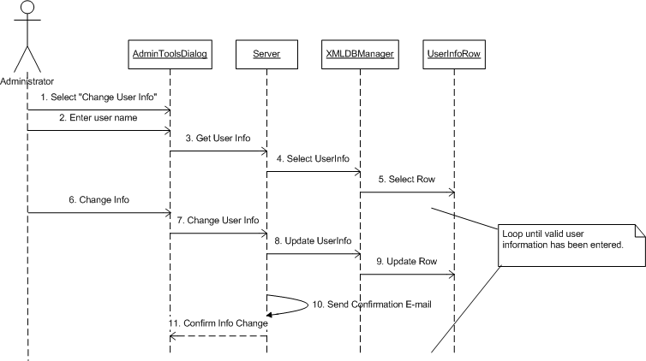

ChangeUserInfo Realization

Basic Course + Successful Alternate Courses

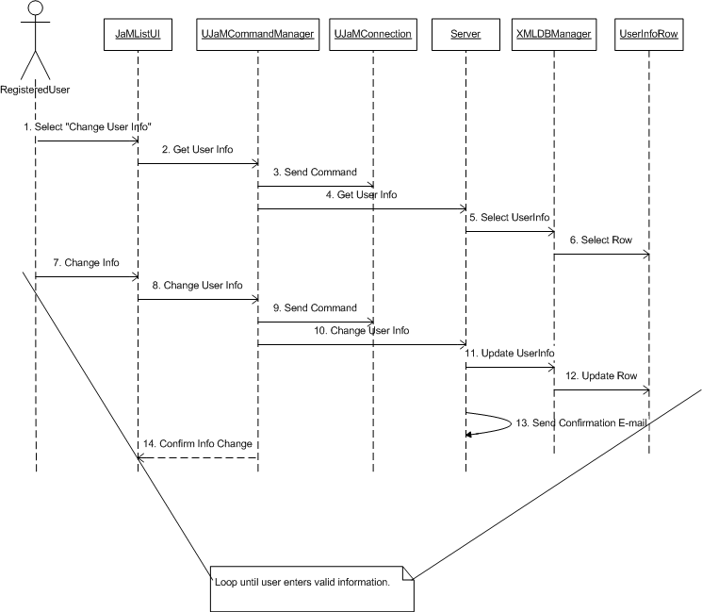

Chat Realization

Basic Course

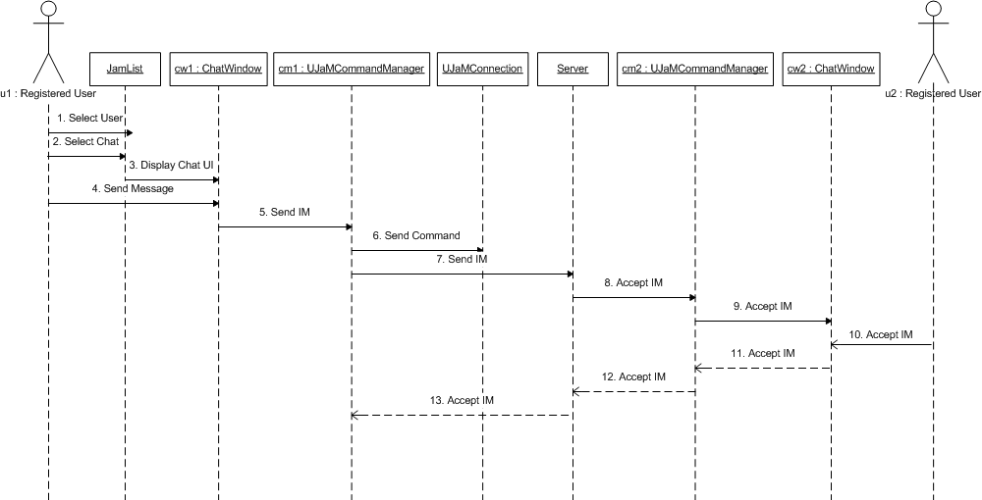

Unsuccessful Alternate Course 1

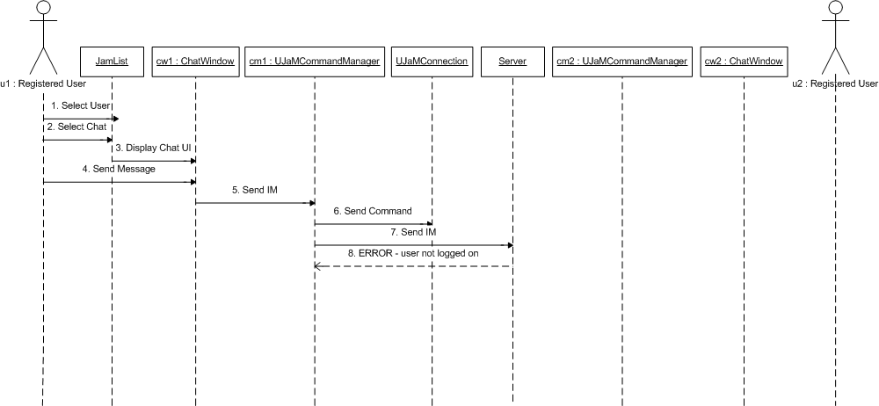
ConnectToAIM Realization

Basic Course

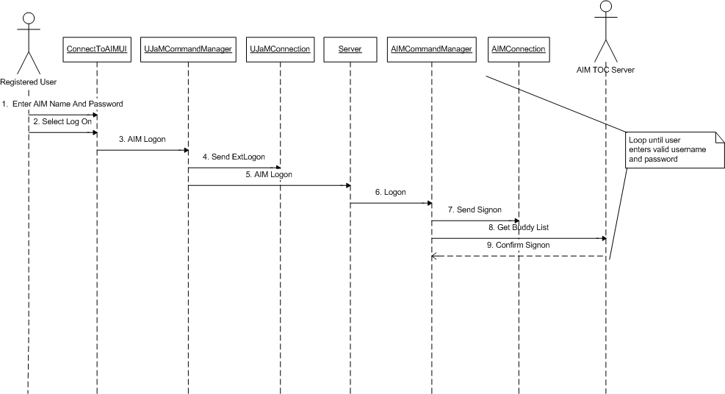
DeleteJammer Realization

Basic Course

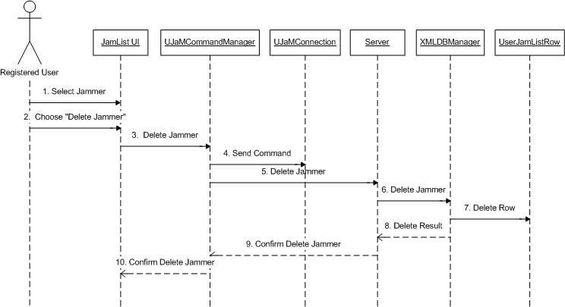

DisableExternalCommunication Realization

Basic Course

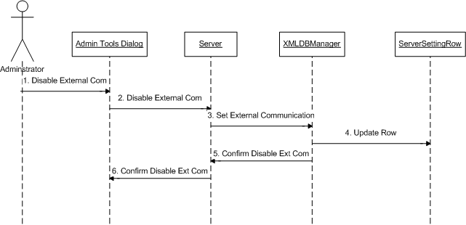

DisconnectFromAIM Realization

Basic Course

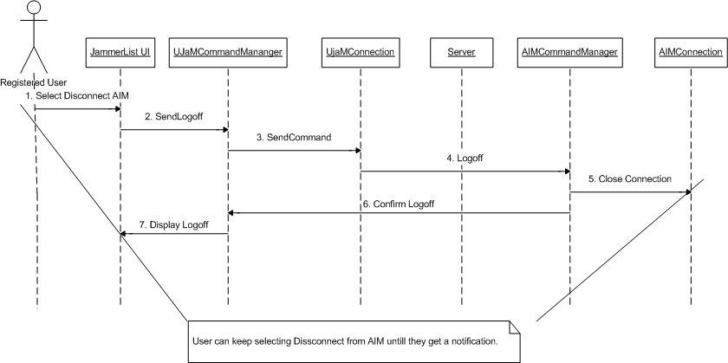

EnableExternalCommunication Realization

Basic Course

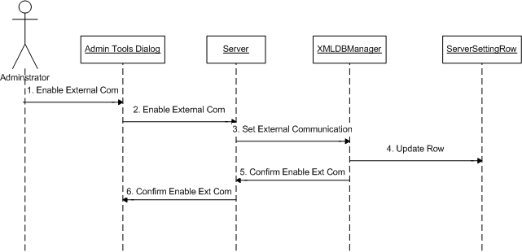

Logoff Realization

Basic Course

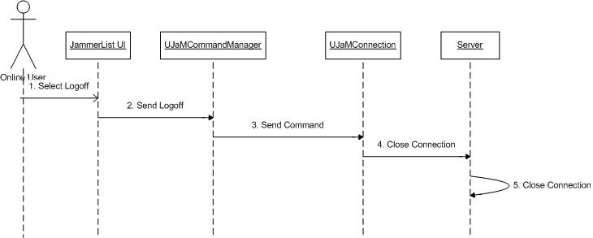

Logon Realization

Basic Course + Successful Alternate Courses

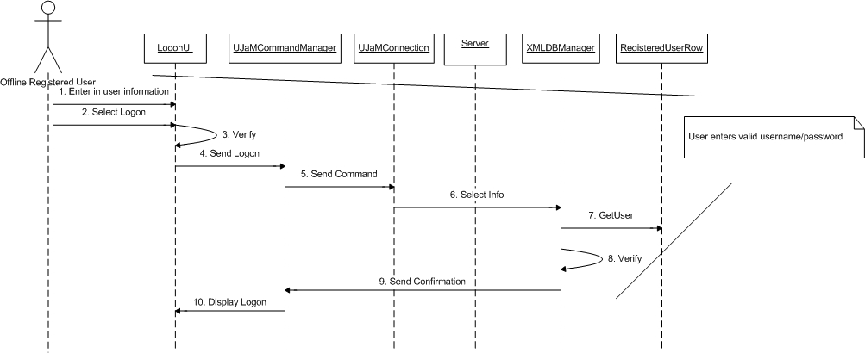

NewUser Realization

Basic Course + Successful Alternate Courses

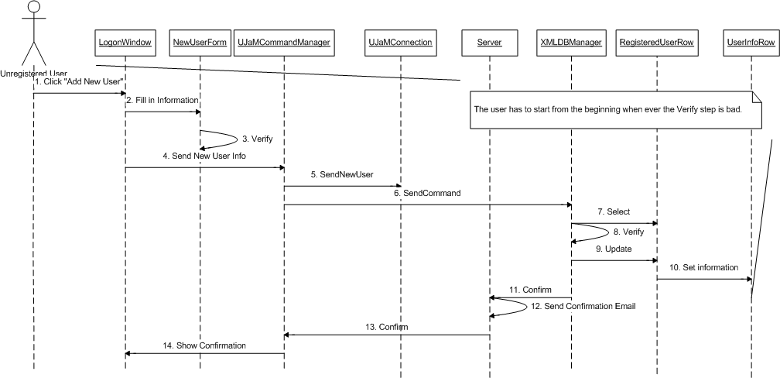

SetAwayMessage Realization

Basic Course

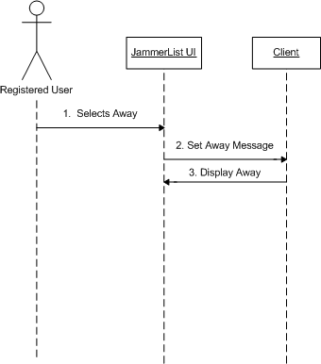

SetConnectionMode Realization

Basic Course

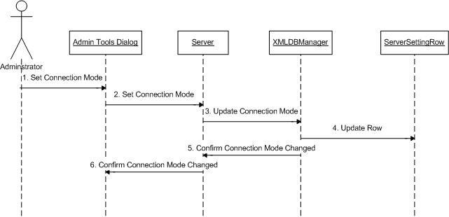

Logical Design

<< Boundary >> Package

- ChatWindow
- NewUserForm
- ChangeUserInfoDialog
- JammerList
- LogonWindow
- ServerConsole
- AdminToolsDialog
- AdminLogonWindow

<< Control >> Package

- Server
- Client
- UJaMCommandManager
- UJaMConnectionManager
- AIMCommandManager
- UJaMConnection
- AIMConnection
- XMLDBManager

<< Entity >> Package

- UserJamListRow
- UserInfoRow
- ChatLogRow
- RegisteredUserRow
- ServerSettingRow

Detailed Design

UJaM: Main

UJaM is organized into four packages or layers: Interfaces, Command, Network, and Data (see Figure 0). The Interfaces layer is at the top level, containing all classes concerned with user interaction and high-level system control. The Command layer contains classes concerned with the interpretation of user actions to commands that the underlying system can understand. The Network layer contains classes concerned with low-level communication between client and server, i.e. network connections and client connection modes. The Data layer contains classes concerned with data handling, such as database management and abstract data types for object-oriented data storage and control.

Figure 0

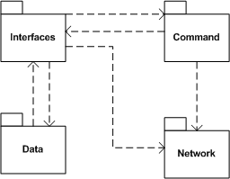

UJaM: Interface

The Interfaces layer is at the top level, containing all classes concerned with user interaction and high-level system control. Users of the system only interact with modules on this level. (See Figure 1).

Class Descriptions

  - NewUserForm
Purpose: To allow user to enter in and send registration information.
Major Features: Has fields for the user to request a username, enter in a password, and enter in a password. This form can be reached from the LogonWindow.
Relationships: Has a 1-1 relationship with LogonWindow.

  - LogonWindow
Purpose: To allow the user to enter in a username and password so that they may logon to the system.
Major Features: Has fields for the user to enter in their username and password. Also, a list of available chat servers will be shown to him. The user must then select from the available servers, and then they may connect.
Relationships: Is required for the Client class. Must have a LogonEventManager. It is necessary for the Client Interface to exist.

  - LogonEventManager
Purpose: To listen to when the user pushes a button on the LogonWindow
Major Features: User has the option to either create a new user name or (after entering in their username and password) logon to the system.
Relationships: This class is necessary for LogonWindow to exist.

  - ChangeUserInfoDialog
Purpose: To allow a user to change the information in their profile (such as their password or e-mail address).
Major Features: This UI simply has fields for the user to enter in any information they would like to modify.
Relationships: This UI can be reached from a button on the JammerList UI (it has a 1-1 relationship with it).

  - JammerList
Purpose: To display the list of users on this Jammer’s jamlist.
Major Features: Can display Jammers and AIM buddies. This window also has all the main menu features for the client UI (File, Edit, Help, etc…).
Relationships: Must have an EventListManager (to listen for button events, etc.), and has a 1-1 relationship with ChangeUserInfoDialog. It is necessary for the Client Interface to exist.

  - ListEventManager
Purpose: To listen for events on the JammerList UI.
Major Features: Listens for various actions such as: adding a jammer to the jamlist, removing a jammer, changing user info, logging on/off of the system, starting a chat, etc.
Relationships: Is necessary for the JammerListUI to exist.

  - ChatWindow
Purpose: To display the conversation going on between two jammers.
Major Features: Has a “chat” area where the history of the conversation is displayed and has an area for a jammer to enter in a message to be sent.
Relationships: Is necessary for the Client Interface to exist. Needs a ChatEventManager to exist.

  - ChatEventManager
Purpose: To listen for events that occur on the ChatWindow
Major Features: Listens for events, such as “send”.
Relationships: Is necessary for the ChatWindow to exist.

  - Client
Purpose: Acts as the main interface for the client UI.
Major Features: Is simply composed of a JammerList, LogonWindow, and ChatWindows.
Relationships: Must have ChatWindow, JammerList, and LogonWindow to exist. Extends the UJaMConnectionListener. Uses the Broadcast Manager to get a list of availaber servers during logon. Also has a UJaMConnectionManager to manage the various chats that may occur during a session. (See Figures 5, 7)

1.10 AdminLogon
Purpose: To allow the administrator to logon to UJaM.
Major Features: Has fields for the administrator to enter in the administrator name and password.
Relationships: Has a 1-1 relationship with the ServerConsole.

1.11 AdminToolsDialog
Purpose: To allow the administrator to change the various server settings.
Major Features: Has radio buttons to select what mode to operate the server in and whether or not to allow external communication (ie- with AIM). The system starts in default settings, but the administrator has the option of changing them.
Relationships: Has a 1-1 relationship with the ServerConsole.

1.12 ServerConsole
Purpose: Allows the administrator to send messages to users of the system and send any necessary emails.
Major Features: Has a message area that allows the administrator to enter in messages.
Relationships: Is necessary for the Server Interface to exist.

1.13 Server
Purpose: Acts as the main interface for the server UI.
Major Features: Simply has composed of a ServerConsole.
Relationships: Must have a ServerConsole to exist. Extends the UJaMConnectionListener. Has a BroadcastManager to listen for server requests from the client. Also has a UJaMConnectionManager to manage connections between users. For data management, the Server also contains an XMLDBManager to handle database commands. The Server also extends the UJaMCommandListener. It uses a UJaMCommandManager to send and receive commands to clients. (See Figures 5, 7, 8).

Figure 1
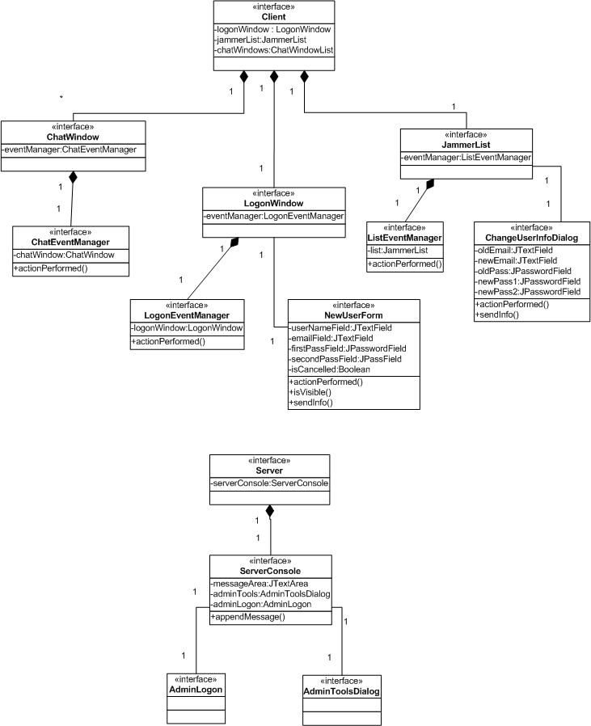

UJaM: Command

The Command layer contains classes concerned with the interpretation of user actions to commands that the underlying system can understand.

Class Descriptions

  - CommandManager
Purpose: act as an abstract command handler.
Major Features: this class is a thread which sends and listens for commands.
Relationships: Inherited by UJaMCommandManager and AIMCommandManager.

  - UJaMCommandManager
Purpose: to send and receive UJaM commands.
Major Features: list of command methods are shown in class diagrams. Also, look at the back of the document for specifications of the command protocol.
Relationships: Extends the CommandManager. Uses a CommandListener to handle incoming commands. Cannot exist without a UJaMCommandParser. Has a many-1 relationship with the UJaMConnectionManager. (See Figure 6).

  - UJaMCommandListener
Purpose: to listen for incoming commands.
Major Features: refer to class diagrams to see list of commands this class handles. Refer to the communication protocol for further details.
Relationships: Has a many-many relationship with the UJaMCommandManager.

  - AIMCommandManager
Purpose: to handle commands to interface with AIM.
Major Features: Has a number of methods which allow for logon/off of AIM, retrieval of buddy lists, etc. Refer to class diagrams and communication protocol for further details.
Relationships: Has a many-1 relationship with the UJaMCommandManager and extends the general CommandManager. Has a 1-1 relationship with AIMConnection. (See Figure 6).

  - UJaMCommandParser
Purpose: to parse commands sent over the network.
Major Features: has methods to parse all the various commands that can be sent over the network. Refer to the class diagram and communication protocol for further details.
Relationships: Is necessary for the UJaMCommandManager to exist.

Figure 2
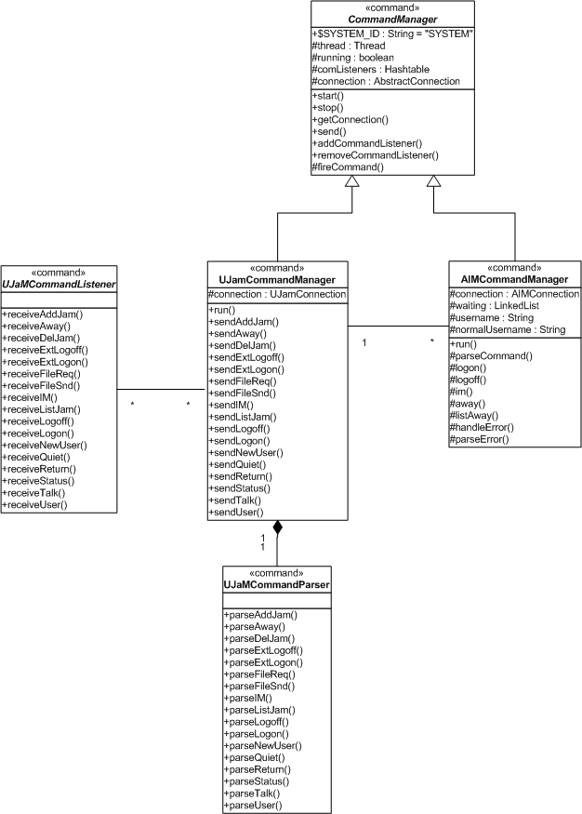

UJaM: Network

The Network layer contains classes concerned with low-level communication between client and server, i.e. network connections and client connection modes. (See Figure 3)

Class Descriptions

  - Connection
Purpose: to be an abstract class which represents a connection between a client and a server.
Major Features: Contains methods to let the user of the class ask whether a connection exists, make a connection, or destroy a connection.
Relationships: This class is a generalization of UJaMConnection and ExtConnection.

  - UJaMConnection
Purpose: To send a receive packets across the network.
Major Features: Uses encode and decode to transform messages sent/received over the network.
Relationships: Extends AbstractConnection. Is used by the UjaMConnectionManager (it has a many to one relationship with it) to act as a connection between a user and the server. Has a 1,2-1 relationship with the UJaMCommandManager. (See Figure 6).

  - UJaMConnectionManager
Purpose: to manage connections between a client and server
Major Features: This class is a thread, which simply makes and listens for messages sent through UJaMConnections. There will be separate connections for separate chats/actions.
Relationships: Uses UJaMConnectionListener and UJaMConnection to achieve its purpose. Has a 1-many relationship with the UJaMCommandManager. (See Figure 6).

  - ExtConnection
Purpose: Act as an abstract class to represent an external connection (ie- a connection to AIM).
Major Features: has abstract methods to get and set whatever logon parameters a specific external connection requires.
Relationships: Generalization of AIMConnection.

  - AIMConnection
Purpose: To allow UJaM users to connect to AIM and talk to their AIM buddies.
Major Features: Uses the TOC protocol to connect to AIM.
Relationships: Extends ExtConnection. Has a 1-1 relationship with AIMCommandManager. (See Figure 6).

  - BroadcastManager
Purpose: To get a list of available chat servers.
Major Features: Sends out a request over the broadcast channel to find chat servers. The servers respond with their IP Address.
Relationships: Used by the Client Interface to display the list of available servers on the logon UI. Used by the Server Interface to listen for Client requests. (See Figure 7).
Figure 3

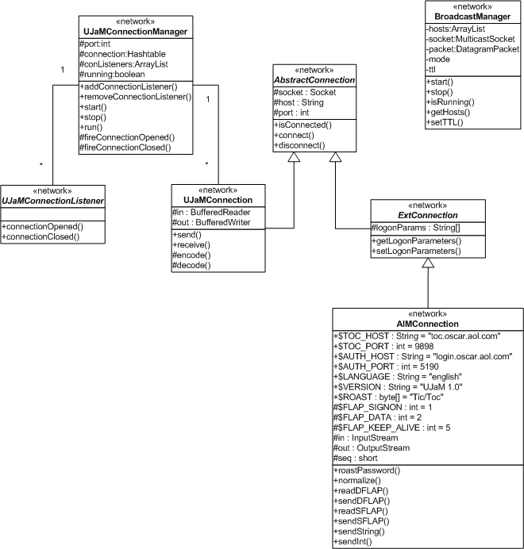

UJaM: Data

The Data layer contains classes concerned with data handling, such as database management and abstract data types for object-oriented data storage and control. (See Figure 4).

Class Descriptions

  - DatabaseManager
Purpose: to allow the insertion, update, deletion, and selection of tuples into the database
Major Features: This class is abstract and each of its methods is abstract. This is done so that in case there is a need to change the implementation of the database, the interface does not change.
Relationships: Inherited by XMLDBManager

  - XMLDBManager
Purpose: to implement the abstract methods of DatabaseManager.
Major Features: This class implements the database manager methods for an XML database
Relationships: Has a one to many relationship with the DatabaseRow class. Has a 1-to-1 relationship with the Server. (See Figure 8).

  - DatabaseRow
Purpose: to represent a row in a database table
Major Features: contains accessor methods to get all the relevant information for this database row- the table it belongs in, the columns of the table, etc.
Relationships: DatabaseRow is an abstract class. It has a many to one relationship with XMLDBManager.

  - UserInfoRow
Purpose: Represents a row in the database table that contains all the user information of a particular user (username, password, e-mail address).
Major Features: Every user profile is actually going to be stored in a separate XML file. Each profile is to be uniquely identified by the username.
Relationships: Extends DatabaseRow.

  - UserJamListRow
Purpose: Represents a row in a database table that contains the jamlist for a particular user.
Major Features: Every user’s jamlist will be stored in a separate XML file. Duplicates are not to be allowed in the list. Each list is to be uniquely identified by the username.
Relationships: Extends DatabaseRow.

  - ChatLogRow
Purpose: Represents a row in a database table that contains the path where the log of a particular chat can be found.
Major Features: Chat Logs are to be uniquely identified by the users, the date of the chat, and the start time of the chat.
Relationships: Extends DatabaseRow.

  - ServerSettingRow
Purpose: Represents a row in a database table that contains the settings for the server (settings regarding whether or not the server is allowing external communication and the mode of the chat – peer to peer or client-server).
Major Features: Whether or not external communication (out to AIM for example) is allowed is to be stored as a Boolean, and the mode is to be stored as an int.
Relationships: Extends DatabaseRow.

  - RegisteredUserRow
Purpose: to represent the list of all registered users on this server.
Major Features: will not allow duplicates of usernames. Also, there is to be a limit to the size of the username.
Relationships: Extends DatabaseRow.
Figure 4

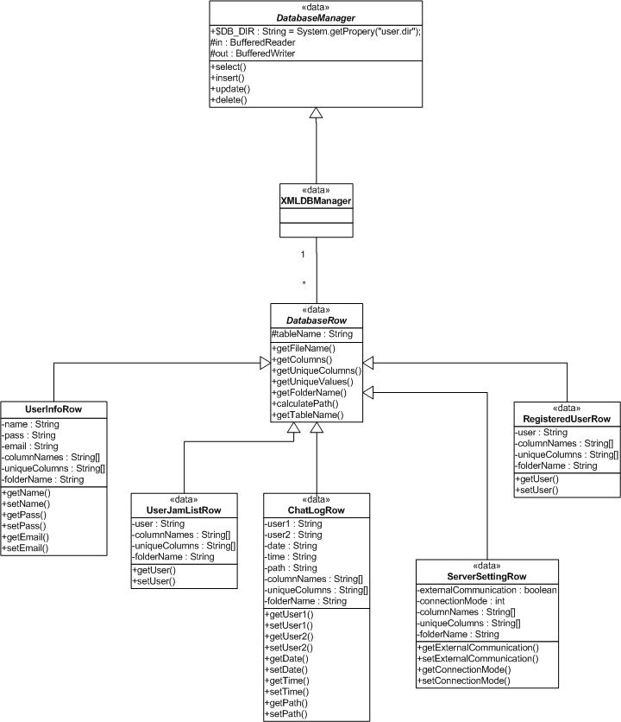

UJaM: Interface-Command Association

Figure 5

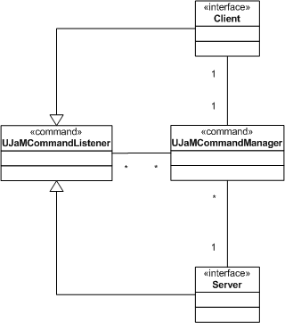

UJaM: Command-Network Association

Figure 6

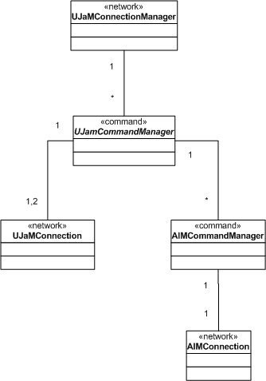

UJaM: Interface-Network Association

Figure 7

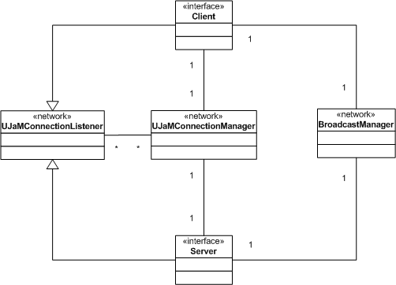

UJaM: Interface-Data Association

Figure 8

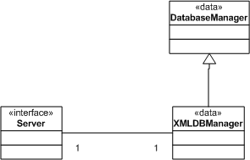

Integration Test Plan

Test Case Item | Network/Command Interaction
ID | send
Purpose of Test | Can send command through the wire specified by the UJaM communication protocol
Module Interactions and/or Items Being Tested | UJaMCommandManager, UJaMConnection
Input(s) | 1. The command specified by the communication protocol
Expected Result(s) | The command is sent successfully
Actual Result(s) | N/A
Special needs and procedures | None

Test Case Item | Network/Command Interaction
ID | receive
Purpose of Test | Can receive command through the wire specified by the UJaM communication protocol
Module Interactions and/or Items Being Tested | UJaMCommandManager, UJaMConnection
Input(s) | 1. The command specified by the communication protocol
Expected Result(s) | The command is received successfully
Actual Result(s) | N/A
Special needs and procedures | None

Test Case Item | Server/Data Interaction
ID | Insert - 1
Purpose of Test | To test if the database manager can interpret the insert command from the server and insert the information into the database
Module Interactions and/or Items Being Tested | Server, DatabaseManager, DatabaseRow
Input(s) | 1. The data to be inserted to the database
Expected Result(s) | The database gets updated with the newly inserted data
Actual Result(s) | N/A
Special needs and procedures | None

Test Case Item | Server/Data Interaction
ID | Insert - 2
Purpose of Test | To test if the database manager can interpret the insert command from the server and insert the information into the database
Module Interactions and/or Items Being Tested | Server, DatabaseManager, DatabaseRow
Input(s) | 1. input is invalid
Expected Result(s) | Database manager reports an error back to the server
Actual Result(s) | N/A
Special needs and procedures | None

Test Case Item | Server/Data Interaction
ID | Select
Purpose of Test | To test if the database manager can interpret the select command from the server and select the information from the database
Module Interactions and/or Items Being Tested | Server, DatabaseManager, DatabaseRow
Input(s) | 1. The data to be updated in database
Expected Result(s) | The desired data from the database gets selected assuming the input is valid and no results if data cannot be found
Actual Result(s) | N/A
Special needs and procedures | None

Test Case Item | Server/Data Interaction
ID | Update 1
Purpose of Test | To test if the database manager can interpret the update command from the server and update the information into the database
Module Interactions and/or Items Being Tested | Server, DatabaseManager, DatabaseRow
Input(s) | - The data to be updated  - The new data
Expected Result(s) | The databases gets updated with the inputted data
Actual Result(s) | N/A
Special needs and procedures | None

Test Case Item | Server/Data Interaction
ID | Update -2
Purpose of Test | To test if the database manager can interpret the update command from the server and update the information into the database
Module Interactions and/or Items Being Tested | Server, DatabaseManager, DatabaseRow
Input(s) | - Data that does not currently exist  - The new data
Expected Result(s) | Database manager reports an error back to the server
Actual Result(s) | N/A
Special needs and procedures | None

Test Case Item | Server/Data Interaction
ID | Update - 3
Purpose of Test | To test if the database manager can interpret the update command from the server and update the information into the database
Module Interactions and/or Items Being Tested | Server, DatabaseManager, DatabaseRow
Input(s) | - The data to be updated  - Invalid data
Expected Result(s) | Database manager reports an error back to the server
Actual Result(s) | N/A
Special needs and procedures | None

Test Case Item | Server/Data Interaction
ID | Delete - 1
Purpose of Test | To test if the database manager can interpret the delete command from the server and remove the information from the database
Module Interactions and/or Items Being Tested | Server, DatabaseManager, DatabaseRow
Input(s) | 1. The data to be deleted from the database
Expected Result(s) | The specified data gets deleted from the database
Actual Result(s) | N/A
Special needs and procedures | None

Test Case Item | Server/Data Interaction
ID | Delete - 2
Purpose of Test | To test if the database manager can interpret the delete command from the server and remove the information from the database
Module Interactions and/or Items Being Tested | Server, DatabaseManager, DatabaseRow
Input(s) | 1. The data to be deleted from the database
Expected Result(s) | If the data does not exist then the database does not change
Actual Result(s) | N/A
Special needs and procedures | None

Test Case Item | Interface/Command Interaction
ID | AddJammer
Purpose of Test | Test the ability to send, receive, and parse the command
Module Interactions and/or Items Being Tested | Client, UJaMCommandManager, UJaMCommandListener, UJaMCommandParser
Input(s) | 1. The Jammer to be added
Expected Result(s) | The command manager receives the command from the interface, successfully parses it, and passes the command to the command listener
Actual Result(s) | N/A
Special needs and procedures | None

Test Case Item | Interface/Command Interaction
ID | Away
Purpose of Test | Test the ability to send, receive, and parse the command
Module Interactions and/or Items Being Tested | Client, UJaMCommandManager, UJaMCommandListener, UJaMCommandParser
Input(s) | 1. The Away Message to be inputted
Expected Result(s) | The command manager receives the command from the interface, successfully parses it, and passes the command to the command listener
Actual Result(s) | N/A
Special needs and procedures | None

Test Case Item | Interface/Command Interaction
ID | DelJam
Purpose of Test | Test the ability to send, receive, and parse the command
Module Interactions and/or Items Being Tested | Client, UJaMCommandManager, UJaMCommandListener, UJaMCommandParser
Input(s) | 1. The Jammer to be deleted
Expected Result(s) | The command manager receives the command from the interface, successfully parses it, and passes the command to the command listener
Actual Result(s) | N/A
Special needs and procedures | None

Test Case Item | Interface/Command Interaction
ID | ExtLogoff
Purpose of Test | Test the ability to send, receive, and parse the command
Module Interactions and/or Items Being Tested | Client, UJaMCommandManager, UJaMCommandListener, UJaMCommandParser
Input(s) | - External connection type  - External user name
Expected Result(s) | The command manager receives the command from the interface, successfully parses it, and passes the command to the command listener
Actual Result(s) | N/A
Special needs and procedures | None

Test Case Item | Interface/Command Interaction
ID | ExtLogon
Purpose of Test | Test the ability to send, receive, and parse the command
Module Interactions and/or Items Being Tested | Client, UJaMCommandManager, UJaMCommandListener, UJaMCommandParser
Input(s) | - External connection type  - External user name
Expected Result(s) | The command manager receives the command from the interface, successfully parses it, and passes the command to the command listener
Actual Result(s) | N/A
Special needs and procedures | None

Test Case Item | Interface/Command Interaction
ID | FileReq
Purpose of Test | Test the ability to send, receive, and parse the command
Module Interactions and/or Items Being Tested | Client, UJaMCommandManager, UJaMCommandListener, UJaMCommandParser
Input(s) | - File  - Size of the file  - Data
Expected Result(s) | The command manager receives the command from the interface, successfully parses it, and passes the command to the command listener
Actual Result(s) | N/A
Special needs and procedures | None

Test Case Item | Interface/Command Interaction
ID | FileSnd
Purpose of Test | Test the ability to send, receive, and parse the command
Module Interactions and/or Items Being Tested | Client, UJaMCommandManager, UJaMCommandListener, UJaMCommandParser
Input(s) | - File  - Size of the file
Expected Result(s) | The command manager receives the command from the interface, successfully parses it, and passes the command to the command listener
Actual Result(s) | N/A
Special needs and procedures | None

Test Case Item | Interface/Command Interaction
ID | IM
Purpose of Test | Test the ability to send, receive, and parse the command
Module Interactions and/or Items Being Tested | Client, UJaMCommandManager, UJaMCommandListener, UJaMCommandParser
Input(s) | - Recipient  2. Message to be sent
Expected Result(s) | The command manager receives the command from the interface, successfully parses it, and passes the command to the command listener
Actual Result(s) | N/A
Special needs and procedures | None

Test Case Item | Interface/Command Interaction
ID | ListJam
Purpose of Test | Test the ability to send, receive, and parse the command
Module Interactions and/or Items Being Tested | Client, UJaMCommandManager, UJaMCommandListener, UJaMCommandParser
Input(s) | - Jammer name
Expected Result(s) | The command manager receives the command from the interface, successfully parses it, and passes the command to the command listener
Actual Result(s) | N/A
Special needs and procedures | None

Test Case Item | Interface/Command Interaction
ID | Logoff
Purpose of Test | Test the ability to send, receive, and parse the command
Module Interactions and/or Items Being Tested | Client, UJaMCommandManager, UJaMCommandListener, UJaMCommandParser
Input(s) | 1. Jammer name
Expected Result(s) | The command manager receives the command from the interface, successfully parses it, and passes the command to the command listener
Actual Result(s) | N/A
Special needs and procedures | None

Test Case Item | Interface/Command Interaction
ID | Logon
Purpose of Test | Test the ability to send, receive, and parse the command
Module Interactions and/or Items Being Tested | Client, UJaMCommandManager, UJaMCommandListener, UJaMCommandParser
Input(s) | 1. Jammer name  - Password
Expected Result(s) | The command manager receives the command from the interface, successfully parses it, and passes the command to the command listener
Actual Result(s) | N/A
Special needs and procedures | None

Test Case Item | Interface/Command Interaction
ID | NewUser
Purpose of Test | Test the ability to send, receive, and parse the command
Module Interactions and/or Items Being Tested | Client, UJaMCommandManager, UJaMCommandListener, UJaMCommandParser
Input(s) | - Name  - E-mail  - Password
Expected Result(s) | The command manager receives the command from the interface, successfully parses it, and passes the command to the command listener
Actual Result(s) | N/A
Special needs and procedures | None

Test Case Item | Interface/Command Interaction
ID | Quiet
Purpose of Test | Test the ability to send, receive, and parse the command
Module Interactions and/or Items Being Tested | Client, UJaMCommandManager, UJaMCommandListener, UJaMCommandParser
Input(s) | - The quiet Jammer
Expected Result(s) | The command manager receives the command from the interface, successfully parses it, and passes the command to the command listener
Actual Result(s) | N/A
Special needs and procedures | None

Test Case Item | Interface/Command Interaction
ID | Return
Purpose of Test | Test the ability to send, receive, and parse the command
Module Interactions and/or Items Being Tested | Client, UJaMCommandManager, UJaMCommandListener, UJaMCommandParser
Input(s) | 1. Jammer name
Expected Result(s) | The command manager receives the command from the interface, successfully parses it, and passes the command to the command listener
Actual Result(s) | N/A
Special needs and procedures | None

Test Case Item | Interface/Command Interaction
ID | Status
Purpose of Test | Test the ability to send, receive, and parse the command
Module Interactions and/or Items Being Tested | Client, UJaMCommandManager, UJaMCommandListener, UJaMCommandParser
Input(s) | - File  2. Size of the file
Expected Result(s) | The command manager receives the command from the interface, successfully parses it, and passes the command to the command listener
Actual Result(s) | N/A
Special needs and procedures | None

Test Case Item | Interface/Command Interaction
ID | Talk
Purpose of Test | Test the ability to send, receive, and parse the command
Module Interactions and/or Items Being Tested | Client, UJaMCommandManager, UJaMCommandListener, UJaMCommandParser
Input(s) | - Jammer name 1 (sender)  - Jammer name 2 (recipient)
Expected Result(s) | The command manager receives the command from the interface, successfully parses it, and passes the command to the command listener
Actual Result(s) | N/A
Special needs and procedures | None

Test Case Item | Interface/Command Interaction
ID | User
Purpose of Test | Test the ability to send, receive, and parse the command
Module Interactions and/or Items Being Tested | Client, UJaMCommandManager, UJaMCommandListener, UJaMCommandParser
Input(s) | 1. Username of the external user
Expected Result(s) | The command manager receives the command from the interface, successfully parses it, and passes the command to the command listener
Actual Result(s) | N/A
Special needs and procedures | None

UJaM Communication Protocol
The following protocol is used to communicate between the UJaM Client and the UJaM Server. It has no relation to communication protocols for external messaging systems such as AIM, etc. The commands are formatted in XML for easier readability and to decrease parsing and conversion time on the server side.

(The following table lists all XML commands. The parent node is assumed to be “UJAM” unless otherwise specified. Items in blue are low priority and may not be implemented.)

Node | Parent | Description
UJAM  [root] | [none] | The root node in every communiqué between client and server. If a communiqué is received that does not begin with this tag, it will be discarded, and an error returned to the sender.
ID |  | The unique identifier for this communiqué.
FROM |  | The user (or ‘SYSTEM’) sending the communiqué.
TO |  | The target user (or ‘SYSTEM’) of the communiqué.
ACK |  | The acknowledgement of some command. It may contain child nodes for more information depending on the command.
ERROR |  | If this is sent instead of an ACK, then some error has occurred and this node contains the error information.
NEW-USER |  | A new user is being created with the information specified by the child nodes. If the process completes successfully, a confirmation e-mail is sent to the user.  The response will be an empty ACK or an ERROR.
PASS | NEW-USER | Specifies the new password.
EMAIL | NEW-USER | Specifies the new email address.
USER |  | A user wants to update their information. Changing information results in a confirmation e-mail to the user.  The response will be an empty ACK or an ERROR
PASS | USER | Specifies the new password. (blank or non-existing mean unchanged).
EMAIL | USER | Specifies the new email address. (blank or non-existing mean unchanged).
STATUS |  | Holds the status information for a particular user. This command is sent from the server to the client to indicate a change in status for someone on the user’s jammer list.  The response will be an empty ACK or an ERROR
LOGON |  | A user is attempting to logon to the system. This tag contains the password for the user.  When the system receives the command it will forward the command to all users that have this user on their Jam List.  The response will be an empty ACK or an ERROR.
LOGOFF |  | A user is logging off the system.  When the system receives the command it will forward the command to all users that have this user on their Jam List.  There is no ACK nor ERROR for this command.
TALK |  | Sets up the connection between two clients regardless of peer to peer or client server connection.  When the system is in “client - server” mode, USER2 receives the TALK, it should return an ACK to USER1. When USER1 receives the ACK, they can begin the IM session. If USER2 sends a rejection ACK then USER1 will do nothing.  When the system is in “peer – peer” mode, USER2 receives the TALK, he will send an ACK to USER1 and begin listening for direct connection from USER1. When USER1 receives the ACK, it sets up connection to USER2 and begins IM session.  The mode will be specified by the server when the TALK command is relayed to USER2. (see MODE node)  ACK values: 0 = reject, 1 = accept
MODE | TALK | The connection mode for communication between users.  0 = UNKNOWN  1 = CLIENT-SERVER  2 = PEER-TO-PEER
IM |  | An instant message to the user specified in the ‘TO’ node.  If a user closes IM window, then session between them ends. Meaning if they want to talk again, the session would have to be reinitialized using the TALK command.  The response will be an empty ACK or an ERROR
QUIET |  | Closes an IM session when a USER1 closes their IM window. If USER2 still has their window open and continues to send messages to USER1, then the IM session will have to be reinstated through the TALK command.  The response will be an empty ACK or an ERROR
AWAY |  | Contains the away message chosen by the user as returned by the LIST-AWAY command, or a new message.  When the system receives the command it will forward the command to all users that have this user on their Jam List. If the chosen message is not on the user’s away message list, it will be added.  The response will be an empty ACK or an ERROR
RETURN |  | An empty tag indicating this user has returned from being away.  The response will be an empty ACK or an ERROR.
LIST-JAM |  | An empty tag requesting a list of jammers for this user.  The response will be an ERROR or an ACK containing user status specifications for each jammer on the user’s list.
ADD-JAM |  | Contains the user name to add to this user’s jammer list.  The response will be an ERROR or an ACK containing the user status for the added jammer.
DEL-JAM |  | Contains the user name to remove from this user’s jammer list  The response will be an empty ACK or an ERROR.
FILE-REQ |  | Request a file transfer to a user. The contents of this node will contain information about the file to send.  The response will be an ERROR or an ACK containing the target user’s choice to accept the transfer. If the ACK contains a 1, the user accepts and will be listening for a direct connection.
NAME | FILE-REQ | Contains the name of the file to be transferred.
SIZE | FILE-REQ | Contains the size (in bytes) of the file to be transferred.
FILE-SND |  | Send a file directly to a user. At this point there should be a direct connection to the target user’s client.  The response will be an empty ACK or an ERROR.
NAME | FILE-SND | Contains the name of the file to be transferred.
SIZE | FILE-SND | Contains the size (in bytes) of the file to be transferred.
DATA | FILE-SND | Contains the data of the file to be transferred.
EXT-LOGON |  | A user is attempting to log on to an external system with the parameters specified.  The response will be an empty ACK or an ERROR.
TYPE | EXT-LOGON | The type of external system (e.g. AIM).
NAME | EXT-LOGON | The username for the external system.
PASS | EXT-LOGON | The password for the external system.
EXT-LOGOFF |  | A user is logging off an external system (not necessarily from UJaM).  There is no response from this command: the communication channel to the external system will be closed.
NAME | EXT-LOGOFF | The username that is logging off.
TYPE | EXT-LOGOFF | The type of external system (e.g. AIM)
BLOCK |  | The user is blocking the specified user.
UNBLOCK |  | The user is unblocking the specified user.

Project Plan

Schedule
- Setup Team Webpage (01/07/2003 – 01/13/2003)
  - Tim, Michael
- Requirements Phase 1 (01/10/2003 – 01/17/2003)
  - Meet with Client and get initial requirements
    - All Team Members
  - Type initial Phase 1 requirements
    - Kenny
  - Edit Phase 1 requirements
    - All Team Members
  - Finalize Phase 1 requirements
    - Kenny
- Requirements Phase 2 (01/17/2003 – 01/24/2003)
  - Meet with client to further specify requirements
    - All Team Members
  - Write initial use and test cases
    - All Team Members
  - Gather and combine initial use cases
    - Mariam
  - Refine and finalize requirements phase 2
    - Michael, Kenny, Nhut
- Final Requirements Phase (1/24/2003 – 1/31/2003)
  - Meet with client to address any remaining concerns
    - All Team Members
  - Refine and finalize final requirements document
    - Tim, Mariam
  - Get requirements approved by client
    - All Team Members
- Design Iteration 1 (1/31/2003 – 02/07/2003)
  - Convert use cases to sequence diagrams
    - All Team Members
  - Combine diagrams from every team member
    - Kenny and Nhut
  - Refine and Finalize Design Iteration
    - All Team Members
- Design Iteration 2 (02/07/2003 – 02/14/2003)
  - Create classes and VOPC diagrams
    - All Team Members
  - Combine classes from all team members into a single document
    - Michael, Tim, Mariam
- Design Iteration 3 (02/14/2003 – 02/21/2003)
  - Refine and Finalize classes
    - All Team Members
  - Obtain document approval from Client
    - All Team Members
- Code Iteration 1 (01/24/2003 – 2/21/2003)
  - Background Research on messaging
    - Michael, Nhut, Kenny
  - GUI Prototype
    - Nhut, Tim
  - Creation of Command Classes
    - Michael, Kenny, Nhut
  - Research and Initial coding of AIM external connection
    - Michael
  - Initial Coding
    - Michael, Kenny
- Code Iteration 2 (2/21/2003 – 2/28/2003)
  - Coding of six required entity classes
    - Kenny
  - Coding of command classes, and external connections
    - Michael
  - GUI Finalization
    - Nhut, Tim
  - Refinement and Verification of Code.
    - All Team Members.
- Code Iteration 3 (2/28/2003 – 03/07/2003)
  - Module Testing
    - All
  - Code corrections
    - Michael, Kenny
  - Verification
    - Mariam
- Final Code Iteration (03/13/2003 – 03/13/2003)
  - Testing
    - Nhut, Tim, Mariam, Kenny
  - Code corrections
    - Kenny, Michael

Project Risks

Having done further work on this project has resulted in a re-evaluation of several project risks originally proposed in our requirements document. The risks which have required updating are as follows.

Knowledge Constraints

Description:
The team members have different skill sets, so not every member is familiar with design languages such as UML. Also, not all team members have experience with Java implementations of multi-threading, TCP/UDP sockets, e-mail, etc.
Update:
The diverse skill set provided by the team members has proven to be a good fit with assorted tasks that are required of this project. As a result, there have been no portions of this project, thus far, in which a lack of knowledge has resulted in a large setback.

Client Time Constraint

Description:
Our client is a professor at a University who occasionally goes out of town for long periods of time.
Update:
The client has always been available by some form of communication, whenever a pressing concern has arisen regarding requirements of the system.

Glossary
Administrator – The user of the system with additional rights to control server settings, view logs, and other supplementary options. The administrator may only access the system from the Server location.

Jam List – List of users of the system and their online/offline status that is displayed for each user of the system.

Jammer – Refers to registered users of the system.

User – A standard user of the system. Also referred to as a Jammer.

Username – The name under which a client appears as on the system.

